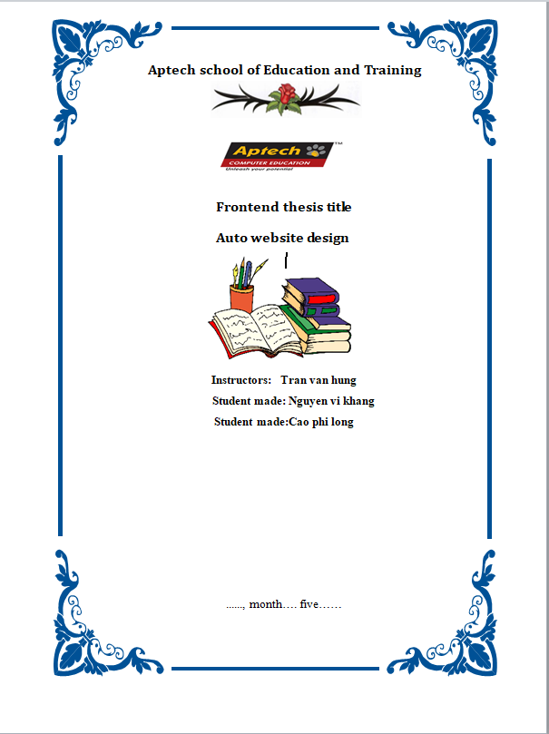

Table of Contents

1.Introduction.

-Company Introduction. 1

-Main missions. 2

-Hardware Requirements. 3

-Software Requirements 4

2.Analysis-Design.

**-**Request Analysis 5

-Use Case. 6

-Site Map.

-Folder directory tree.

3.Installation Instruction.

-Hardware Requirements. 7

-Software Requirements. 8

-Installation Instruction. 9

4.User Manual. Home Page

-Navigation Bar 10

-Header 11

-Preview – Contact – Testimonials 12

-Product List 13

-Product Details 14

-Contact 15

-News & Blog 16

-map 17

$$$$$$$$$$$$$$$$$$$$$$$$$$$$$$$$$

Introduction.

I.Company Introduction

-AUTO LK.com is a website focusing on selling middle class and luxury cars. We also provide online order and home delivery.Due to a range of high class customers of the company, the owner wishes to renovate the look and feel of the website thus it could be modern, authentic and bring more value to the business.

II.Main missions.

-The site should work well in all leading browsers including Chrome, IE, Firefox etc.The website is to be developed for the Windows Platform using Bootstrap 3, JavaScript and CSS.

-The site will list all the different branded cars of AUTO LK.com

-Create the look and feel of the website which should be modern and eye catching for the business perspective.

III.Hardware Requirements

-A minimum computer system that will help you access all the tools in the courses is a Pentium 166 or better.

-64 Megabytes of RAM or better.

IV. Software Requirements.

-Visual Code

$$$$$$$$$$$$$$$$$$$$$$$$$$$$$$$$$

|  |
| --- |
| Request Analysis   1. The website is to be created based on the following requirements:  * The Homepage should be created making use of sections with a suitable logo. * The Menu must be included in the website. * Links to subpages such as: * Product List:   1. lamborghini   2. civic * Blog & News * Product Details * About Us * There should be a “Contact Us” page which will have the Address of the Company which should be displayed using GeoLocation API (eg. GoogleMaps) and the email address which when clicked will invoke the local mail client from where they can send an email. |
|  |
| Use Case.   * A use case diagram at its simplest is a representation of a user's interaction with the system that shows the relationship between the user and the different use case in which the user is involved. A use case diagram can identify the different types of users of a system and the different use cases and will often be accompanied by other types of diagrams as well. * In this context, “system” is the website being developed or operated, which is named “AUTO LK.COM” that lists all the products (Cars) and sells them to customers (Actor). Below is the Use case diagram of AUTO LK.COM website:   1. create a new folder and name it   * in the new folder yes, img are the images related to the website       2.create index.html file as homepage   * insert bootstrap link * in the index.html file has an interface with a horizontal bar including: logo, hot selling products, vehicles, information, address, General news, accessories and login information. * The above text is placed in a div with ul and li. The lines are css displayed in color frames.     3.create css   * insert css snippet on homepage * write css code to insert background-color.   4.write css code to insert background-color.   * 3D transforms and javascript create a slideshow carousel * it uses custom images, text or branding * browsers that use the page rendering API block scrolling * inaccessible carousel, carousel of custom buttons left , right   5.best selling product line   * it is built in div tag with star functions: * Show pictures of cars being sold at the store * When you click to view details, you will see the torque and capacity specifications of the car * In the detail view, there is a buy-now section for customers to enter information: car line, maid and warranty. * Each product has an address for customers to find easily.      |  | | --- | | 6.vehicles are being sold at the store   * built in div tag.Shows a variety of vehicles. * car price indicator * In the button insert a tag, put the pre-made test registration file. * Test drive registration page creates a real driving feeling by online form * with extremely interesting 3D configuration * built in table . function * with lines of css code to create authenticity for testers     7.information about auto   * This section is only for customers to refer to and distinguish more clearly about the vehicle.   8.address   * Create a small slide inside a div that shows the email address of the store owner for easy contact * put in the slide will be more eye-catching * Map location shows the store location.     9.general news   * different types of cars * about color * Designs * torque and displacement of the vehicle   10.auto accessories   * include: * filter, spark plug, engine air filter, brake pads, oil, vehicle class, battery. * Essential tools of a car. * A use case diagram at its simplest is a representation of a user's interaction with the system that shows the relationship between the user and the different use case in which the user is involved. * A use case diagram can identify the different types of users of a system and the different use cases and will often be accompanied by other types of diagrams as well. * In this context, “system” is the website being developed or operated, which is named “AUTO LK” that lists all the products (Cars) and sells them to customers (Actor). Below is the Use case diagram of AUTO LK website     **thank teachers and friends lisstened. teachers and friends**  **teachers and friends** | |

-